**Course Two Week Four: LOOKUP Library Activity Instructions**

Open the file contained within the folder name shown above.

We want Excel to search through the book ISBN codes in this sheet:

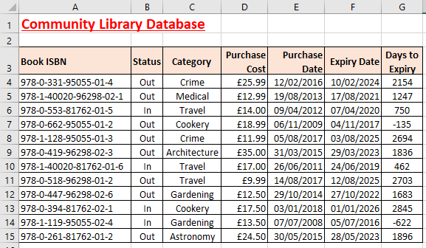

*The whole spreadsheet is the lookup table*

When Excel finds the ISBN code in the first column that exactly matches the ISBN code in the merged cell **B18**, we want Excel to complete cells **B19:B22** with the correct information for that book:

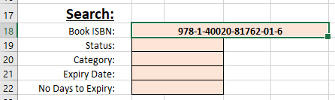

*The ISBN is the code the lookup formula will find an exact match for.*

First create a range name for all the data in your main spreadsheet table (**A4:G15**).

Also create a range name for the merged cell **B18** where you will keep changing the book ISBN code.

In merged cell **B19** create an exact match lookup formula to return the book status from column **B** (the 2nd column in your lookup table).

*Remember - exact match lookup formulae have an extra variable:* ***=VLOOKUP(Cell to lookup, Table range, Column ref, FALSE)***

Copy the formula down to merged cell **B22** and then edit each formula by changing the column reference to return the correct book data.

Change the ISBN code in merged cell **B18** to **978-0-662-95055-01-2** to check that all your formulae work.

Use **Save As..**. to save the file in your own new Excel work folder.